Welcome To
Trinity Lutheran Church
Lutheran Church—Missouri Synod
A Stephen Ministry Congregation

1354 South Otsego Avenue
Gaylord, Michigan 49735
Church Phone: (989) 732-4816

Church Email: secretary@trinitygaylord.com
www.trinitygaylord.com

Office Hours: Monday through Friday 9am – 1pm

OUR PURPOSE
…is to LOVE GOD, LOVE OTHERS, AND SERVE THE WORLD by worshiping the Lord Jesus, bringing our members into Christ-like maturity, and equipping them through Word and Sacrament for their mission and ministry. We go heart to heart into the world with Jesus, sharing His love, caring for one another, praying, and bringing the lost into a relationship with Christ, by the working of the Holy Spirit.

November 13, 2022
Twenty-Third Sunday after Pentecost
Preacher: Rev. Ken Bernthal

ABOUT OUR WORSHIP
We welcome all who gather here today! We are blessed to celebrate together the mercy, grace, and love we have from God through the death and resurrection of our Lord Jesus Christ.

Children: Families with children are very welcome here. Having children in church is important so they can begin to learn about their faith in Jesus, and it’s good for the whole congregation to see. Please feel comfortable keeping “squirmy” kids in the service. This is where they belong, too!

Pew Cards: Guests and Members, please fill out the Guest/Member card located on the back of the pew in front of you and pass it to the end of the aisle. If you forget you can put it in the offering plate on your way out.

If standing is difficult: Please feel free to remain seated during any portion of the service. Please let an Elder or Usher know if you need communion in your pew seat.

About our celebration of Holy Communion: We celebrate the Lord’s Supper in the confession and glad confidence that, as he says, our Lord gives into our mouths not only bread and wine but his very body and blood to eat and to drink for the forgiveness of sins and to strengthen our union with him and with one another. Our Lord invites to his table those who trust his words, repent of all sin, and set aside any refusal to forgive and love as he forgives and loves us, that they may show forth his death until he comes.

Because those who eat and drink our Lord’s body and blood contrary to that which is stated above do so to their great harm, and also because Holy Communion is a confession of the faith which is confessed at this altar. Anyone who is not yet instructed, in doubt, or who hold a confession differing from that of the Lutheran Church—Missouri Synod, and yet desire to receive the sacrament, are asked first to speak with Pastor. Those not communing are still invited to come forward for a blessing from Pastor, and you may indicate this by crossing your arms over your chest.
TTTTTT
GREETING

P Peace be with you.
C And also with you.

T ORDER OF SERVICE T
(The liturgy is from Divine Service Setting four LSB pg. 203ff)

OPENING HYMN
Christ Is Our Cornerstone LSB 912 please stand on v.3
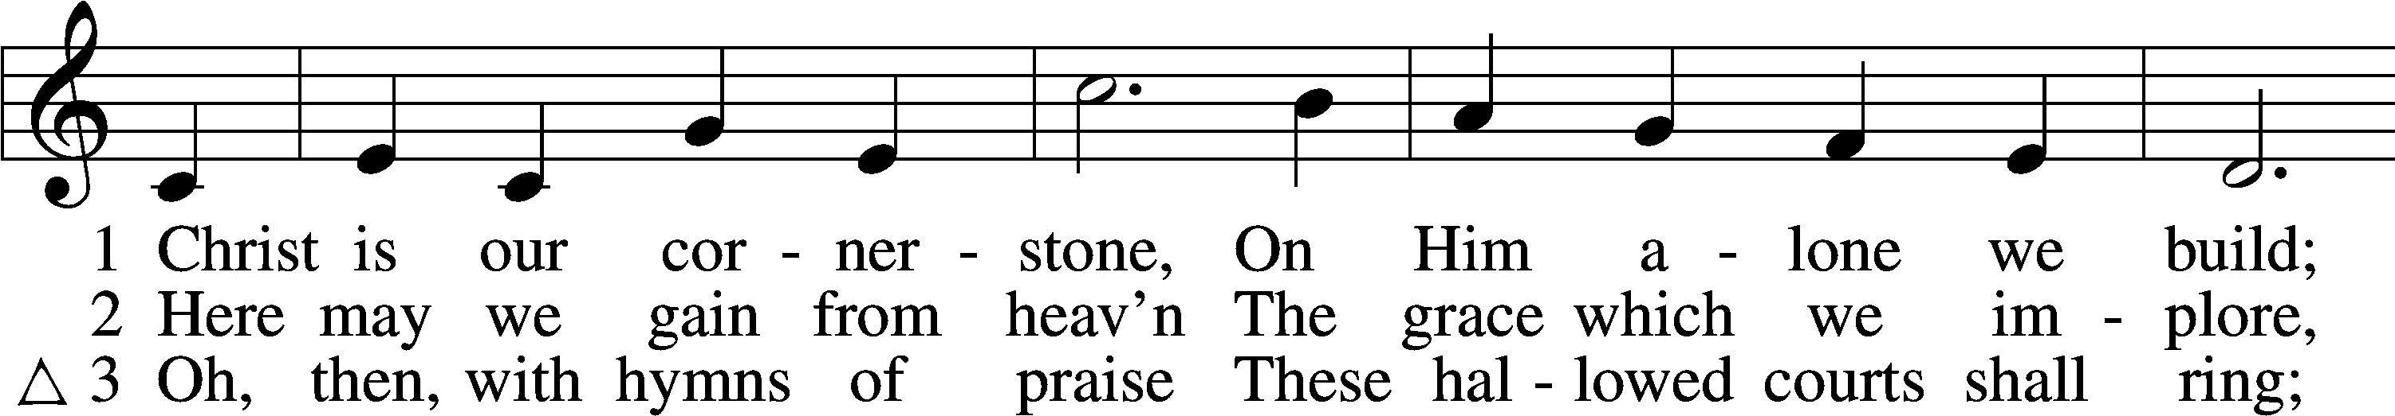
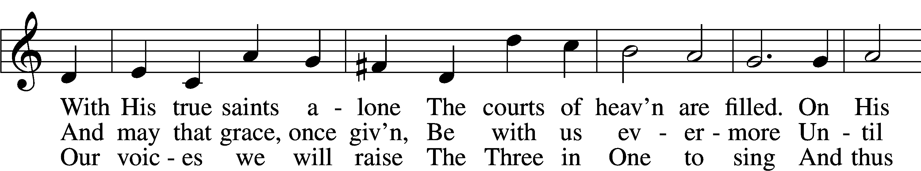
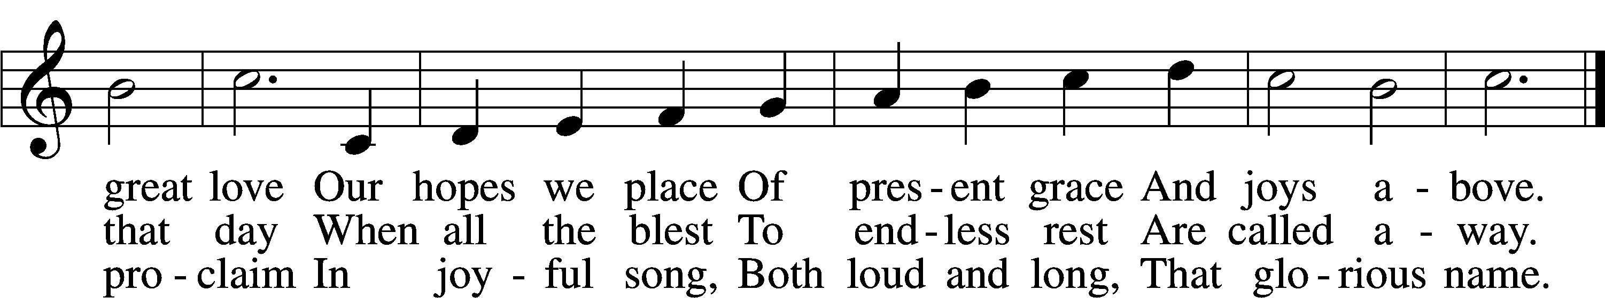

CONFESSION and ABSOLUTION
The sign of the cross may be made by all in remembrance of their Baptism.

P In the name of the Father and of the T Son and of the Holy Spirit.
C Amen.
P Our help is in the name of the Lord,
C who made heaven and earth.
P If You, O Lord, kept a record of sins, O Lord, who could stand?
C But with You there is forgiveness; therefore, You are feared.
P Since we are gathered to hear God’s Word, call upon Him in prayer and praise, and receive the body and blood of our Lord Jesus Christ in the fellowship of this altar, let us first consider our unworthiness and confess before God and one another that we have sinned in thought, word, and deed, and that we cannot free ourselves from our sinful condition. Together as His people let us take refuge in the infinite mercy of God, our heavenly Father, seeking His grace for the sake of Christ, and saying: God, be merciful to me, a sinner.
C Almighty God, have mercy upon us, forgive us our sins, and lead us to everlasting life. Amen.
P Almighty God in His mercy has given His Son to die for you and for His sake forgives you all your sins. As a called and ordained servant of Christ, and by His authority, I therefore forgive you all your sins in the name of the Father and of the T Son and of the Holy Spirit.
C Amen.

T SERVICE OF THE WORD T

INTROIT
P Heaven and earth will pass away,
but my words will not pass away.
C I lift up my eyes to the hills.
From where does my help come?
P My help comes from the Lord,
who made heaven and earth.
C The Lord is your keeper;
the Lord is your shade on your right hand.
P The Lord will keep you from all evil;
he will keep your life.
C The Lord will keep your going out and your coming in
from this time forth and forevermore.
A Glory be to the Father and to the Son
and to the Holy Spirit;
as it was in the beginning,
is now, and will be forever. Amen.
P Heaven and earth will pass away,
but my words will not pass away.

KYRIE LSB 204
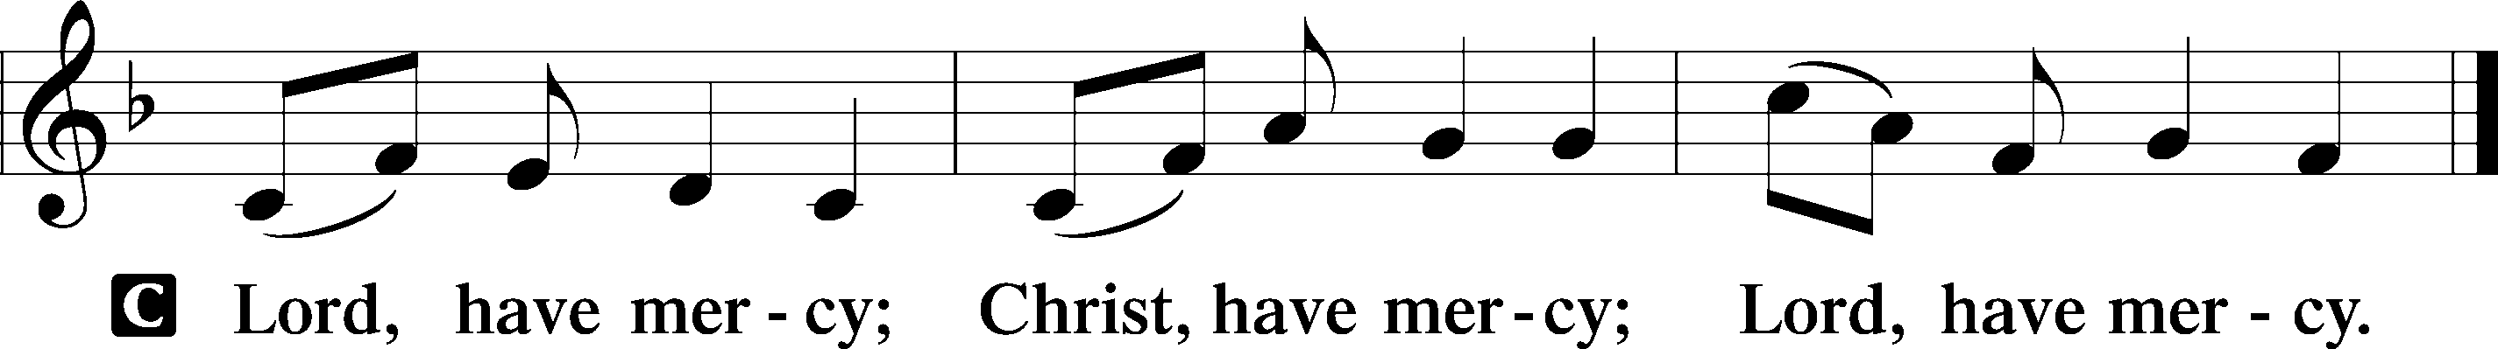

HYMN OF PRAISE
GLORIA IN EXCELSIS LSB 204
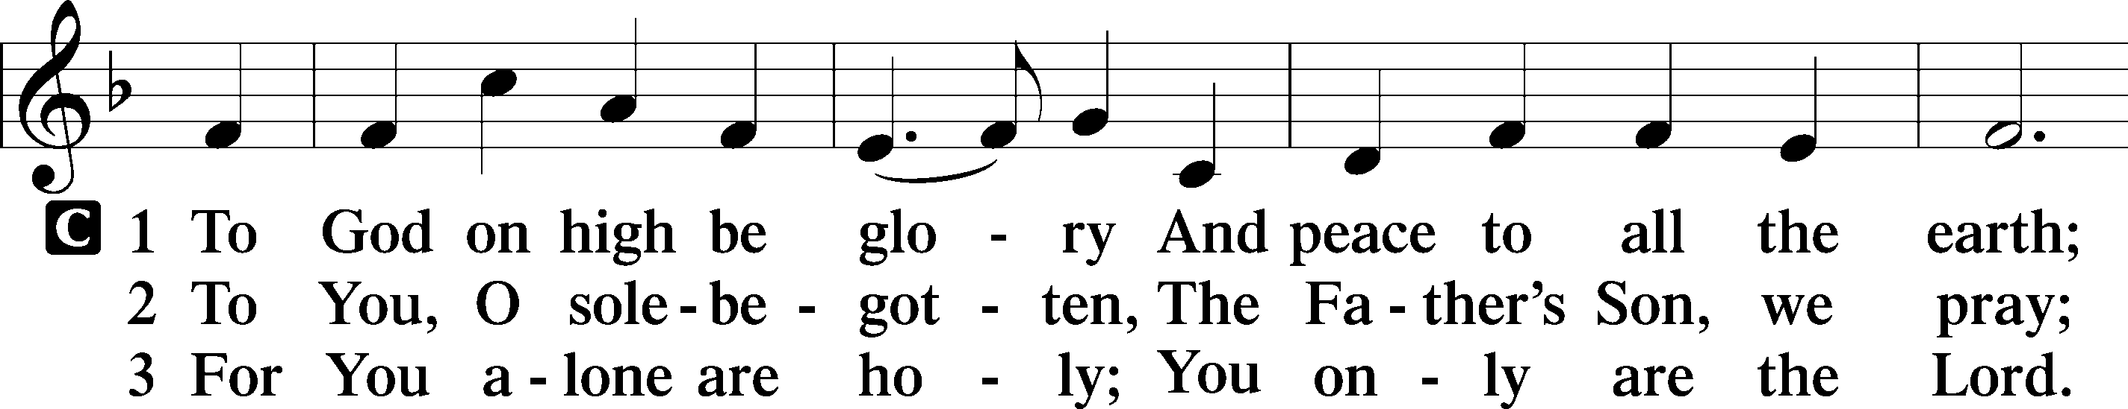
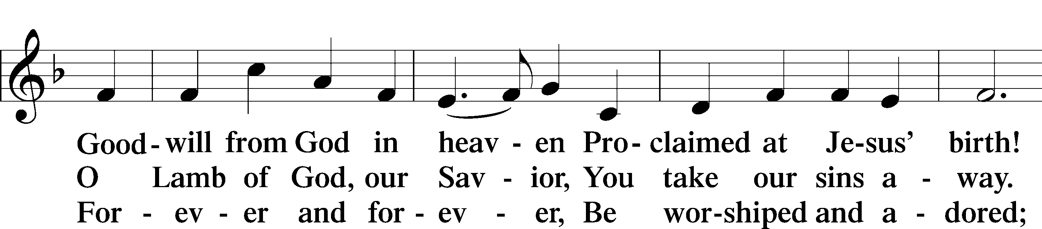
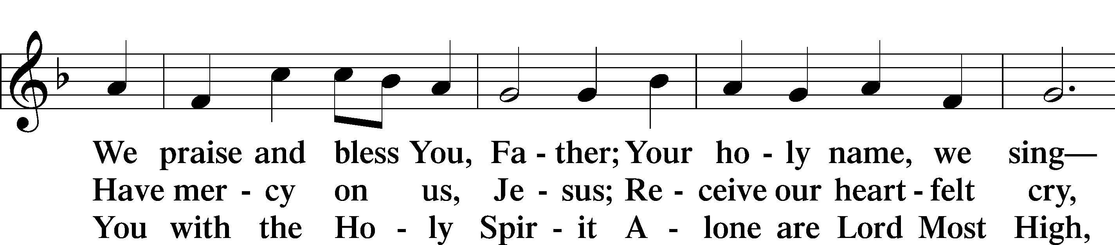
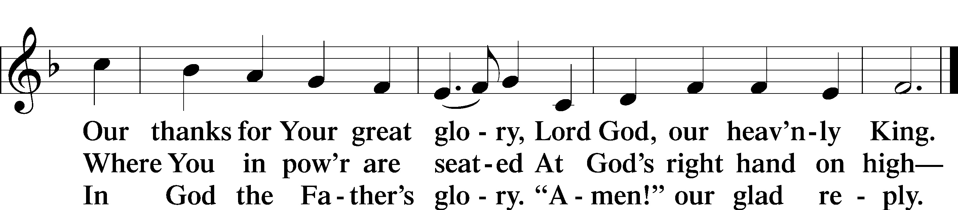

SALUTATION AND COLLECT OF THE DAY
P The Lord be with you.
C And also with you.

P Let us pray.
O Lord, almighty and ever-living God, You have given exceedingly great and precious promises to those who trust in You. Rule and govern our hearts and minds by Your Holy Spirit that we may live and abide forever in Your Son, who lives and reigns with You and the Holy Spirit, one God, now and forever.
C Amen.

Please be seated
OLD TESTAMENT READING Malachi 4:1–6
¹ “For behold, the day is coming, burning like an oven, when all the arrogant and all evildoers will be stubble. The day that is coming shall set them ablaze, says the Lord of hosts, so that it will leave them neither root nor branch. ²But for you who fear my name, the sun of righteousness shall rise with healing in its wings. You shall go out leaping like calves from the stall. ³And you shall tread down the wicked, for they will be ashes under the soles of your feet, on the day when I act, says the Lord of hosts.
⁴“Remember the law of my servant Moses, the statutes and just decrees that I commanded him at Horeb for all Israel.
⁵“Behold, I will send you Elijah the prophet before the great and awesome day of the Lord comes. ⁶And he will turn the hearts of fathers to their children and the hearts of children to their fathers, lest I come and strike the land with a decree of utter destruction.”
P This is the Word of the Lord.
C Thanks be to God.

EPISTLE 2 Thessalonians 3:1–13
¹Finally, brothers, pray for us, that the word of the Lord may speed ahead and be honored, as happened among you, ²and that we may be delivered from wicked and evil men. For not all have faith. ³But the Lord is faithful. He will establish you and guard you against the evil one. ⁴And we have confidence in the Lord about you, that you are doing and will do the things that we command. ⁵May the Lord direct your hearts to the love of God and to the steadfastness of Christ.
⁶Now we command you, brothers, in the name of our Lord Jesus Christ, that you keep away from any brother who is walking in idleness and not in accord with the tradition that you received from us. ⁷For you yourselves know how you ought to imitate us, because we were not idle when we were with you, ⁸nor did we eat anyone’s bread without paying for it, but with toil and labor we worked night and day, that we might not be a burden to any of you. ⁹It was not because we do not have that right, but to give you in ourselves an example to imitate. ¹⁰For even when we were with you, we would give you this command: If anyone is not willing to work, let him not eat. ¹¹For we hear that some among you walk in idleness, not busy at work, but busybodies. ¹²Now such persons we command and encourage in the Lord Jesus Christ to do their work quietly and to earn their own living.
¹³As for you, brothers, do not grow weary in doing good.
P This is the Word of the Lord.
C Thanks be to God.

Please stand as able

ALLELUIA AND VERSE
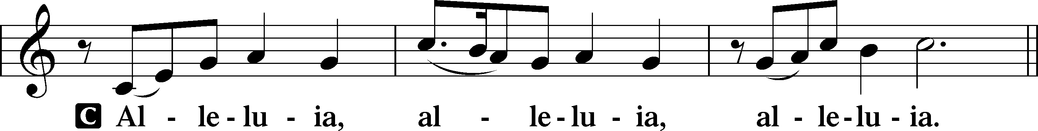
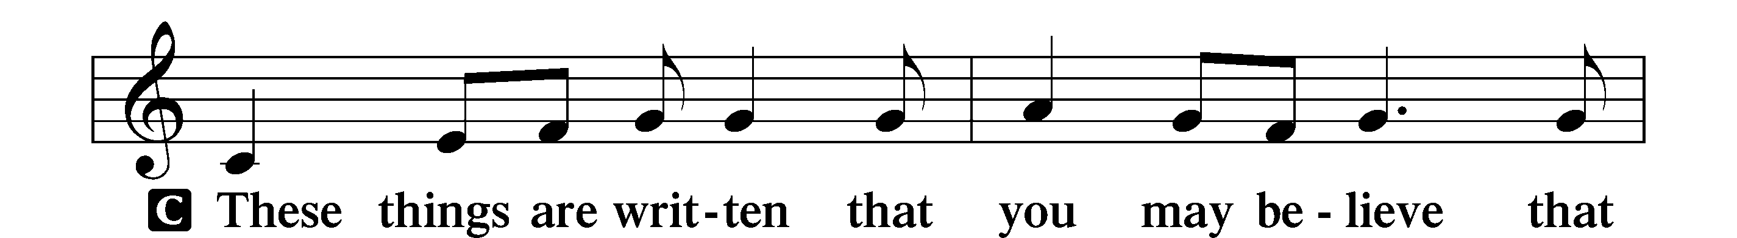
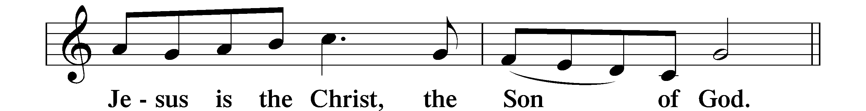
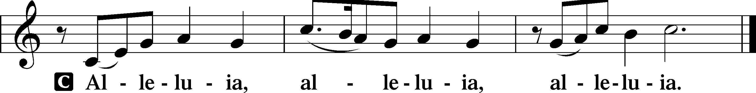

HOLY GOSPEL Luke 21:5–28
P The Holy Gospel according to St. Luke, the twenty-first chapter.
C Glory to You, O Lord.
⁵ and while some were speaking of the temple, how it was adorned with noble stones and offerings, [Jesus] said, ⁶“As for these things that you see, the days will come when there will not be left here one stone upon another that will not be thrown down.” ⁷And they asked him, “Teacher, when will these things be, and what will be the sign when these things are about to take place?” ⁸And he said, “See that you are not led astray. For many will come in my name, saying, ‘I am he!’ and, ‘The time is at hand!’ Do not go after them. ⁹And when you hear of wars and tumults, do not be terrified, for these things must first take place, but the end will not be at once.”
¹⁰Then he said to them, “Nation will rise against nation, and kingdom against kingdom. ¹¹There will be great earthquakes, and in various places famines and pestilences. And there will be terrors and great signs from heaven. ¹²But before all this they will lay their hands on you and persecute you, delivering you up to the synagogues and prisons, and you will be brought before kings and governors for my name’s sake. ¹³This will be your opportunity to bear witness. ¹⁴Settle it therefore in your minds not to meditate beforehand how to answer, ¹⁵for I will give you a mouth and wisdom, which none of your adversaries will be able to withstand or contradict. ¹⁶You will be delivered up even by parents and brothers and relatives and friends, and some of you they will put to death. ¹⁷You will be hated by all for my name’s sake. ¹⁸But not a hair of your head will perish. ¹⁹By your endurance you will gain your lives.
²⁰“But when you see Jerusalem surrounded by armies, then know that its desolation has come near. ²¹Then let those who are in Judea flee to the mountains, and let those who are inside the city depart, and let not those who are out in the country enter it, ²²for these are days of vengeance, to fulfill all that is written. ²³Alas for women who are pregnant and for those who are nursing infants in those days! For there will be great distress upon the earth and wrath against this people. ²⁴They will fall by the edge of the sword and be led captive among all nations, and Jerusalem will be trampled underfoot by the Gentiles, until the times of the Gentiles are fulfilled.
²⁵“And there will be signs in sun and moon and stars, and on the earth distress of nations in perplexity because of the roaring of the sea and the waves, ²⁶people fainting with fear and with foreboding of what is coming on the world. For the powers of the heavens will be shaken. ²⁷And then they will see the Son of Man coming in a cloud with power and great glory. ²⁸Now when these things begin to take place, straighten up and raise your heads, because your redemption is drawing near.”

P This is the Gospel of the Lord.
C Praise to You, O Christ.

NICENE CREED
C I believe in one God,
the Father Almighty,
maker of heaven and earth
and of all things visible and invisible.
And in one Lord Jesus Christ,
the only-begotten Son of God,
begotten of His Father before all worlds,
God of God, Light of Light,
very God of very God,
begotten, not made,
being of one substance with the Father,
by whom all things were made;
who for us men and for our salvation came down from heaven
and was incarnate by the Holy Spirit of the virgin Mary
and was made man;
and was crucified also for us under Pontius Pilate.
He suffered and was buried.
And the third day He rose again according to the Scriptures
and ascended into heaven
and sits at the right hand of the Father.
And He will come again with glory to judge both the living and the dead,
whose kingdom will have no end.
And I believe in the Holy Spirit,
the Lord and giver of life,
who proceeds from the Father and the Son,
who with the Father and the Son together is worshiped and glorified,
who spoke by the prophets.
And I believe in one holy Christian and apostolic Church,
I acknowledge one Baptism for the remission of sins,
and I look for the resurrection of the dead
and the life T of the world to come. Amen.

Please be seated

ALL GOD’S CHILDREN – TALK

SERMON HYMN
Jesus, Savior, Pilot Me LSB 715
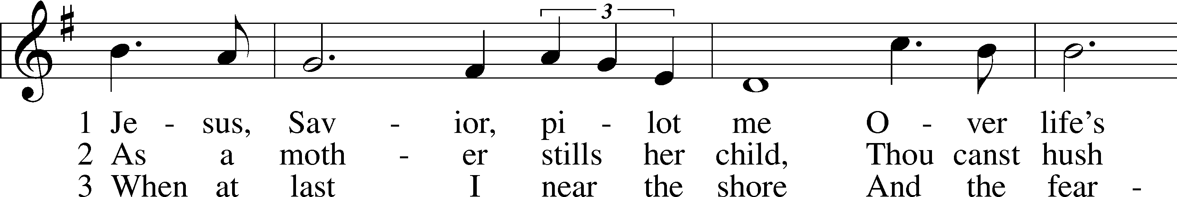
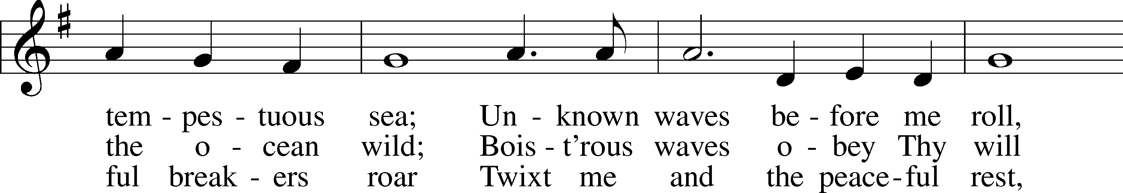
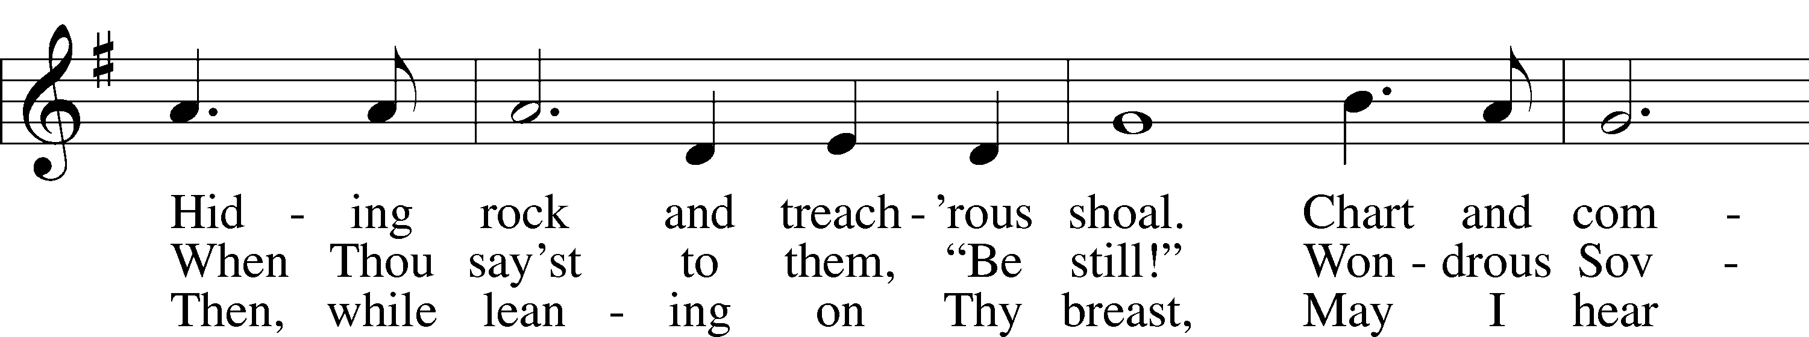
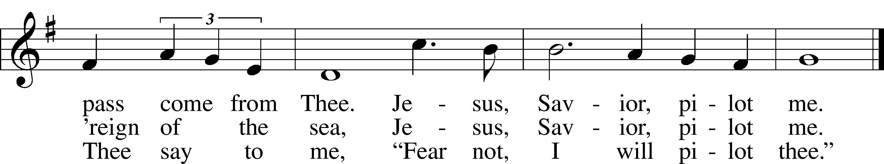

SERMON
Please stand as able

PRAYER of the CHURCH
After each Segment:
P Lord, in Your Mercy,
C Hear our Prayer.
After Final Segment:
P Hear us as we pray in His name and as He has taught us:
LORD’S PRAYER
C Our Father who art in heaven,
hallowed be Thy name,
Thy kingdom come,
Thy will be done on earth
as it is in heaven;
give us this day our daily bread;
and forgive us our trespasses
as we forgive those
who trespass against us;
and lead us not into temptation,
but deliver us from evil.
For Thine is the kingdom
and the power and the glory
forever and ever. Amen.

T SERVICE of the SACRAMENT T

PREFACE LSB 208
P The Lord be with you.
C And also with you.
P Lift up your hearts.
C We lift them to the Lord.
P Let us give thanks to the Lord our God.
C It is right to give Him thanks and praise.
P It is truly good, right, and salutary that we should at all times and in all places give thanks to You, O Lord, holy Father, almighty and everlasting God, for the countless blessings You so freely bestow on us and all creation. Above all, we give thanks for Your boundless love shown to us when You sent Your only-begotten Son, Jesus Christ, into our flesh and laid on Him our sin, giving Him into death that we might not die eternally. Because He is now risen from the dead and lives and reigns to all eternity, all who believe in Him will overcome sin and death and will rise again to new life. Therefore with angels and archangels and with all the company of heaven we laud and magnify Your glorious name, evermore praising You and singing
:
SANCTUS LSB 208
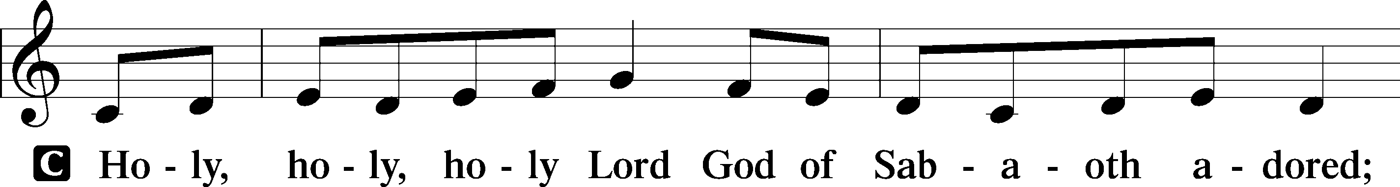
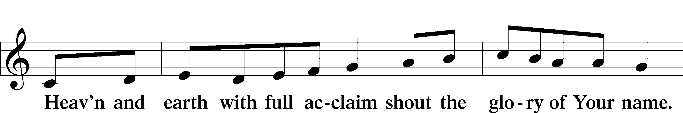
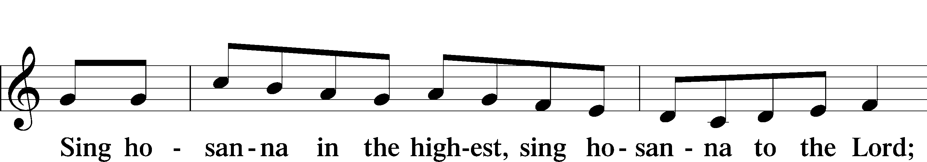

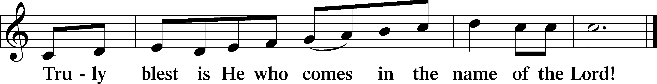

PRAYER OF THANKSGIVING
P Blessed are You, O Lord our God, king of all creation, for You have had mercy on us and given Your only-begotten Son that whoever believes in Him should not perish but have eternal life.

In Your righteous judgment You condemned the sin of Adam and Eve, who ate the forbidden fruit, and You justly barred them and all their children from the tree of life. Yet, in Your great mercy, You promised salvation by a second Adam, Your Son, Jesus Christ, our Lord, and made His cross a life-giving tree for all who trust in Him.

We give You thanks for the redemption You have prepared for us through Jesus Christ. Grant us Your Holy Spirit that we may faithfully eat and drink of the fruits of His cross and receive the blessings of forgiveness, life, and salvation that come to us in His body and blood.

THE WORDS OF OUR LORD
P Our Lord Jesus Christ, on the night when He was betrayed, took bread, and when He had given thanks, He broke it and gave it to the disciples and said: “Take, eat; this is My T body, which is given for you. This do in remembrance of Me.”
In the same way also, He took the cup after supper, and when He had given thanks, He gave it to them, saying: “Drink of it, all of you; this cup is the New Testament in My T blood, which is shed for you for the forgiveness of sins. This do, as often as you drink it, in remembrance of Me.”

PAX DOMINI
P The peace of the Lord be with you always.
C Amen.
AGNUS DEI
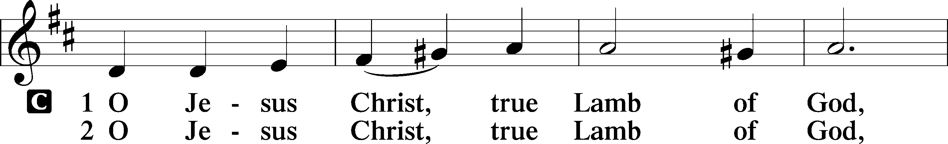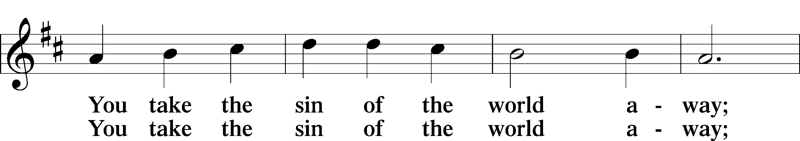
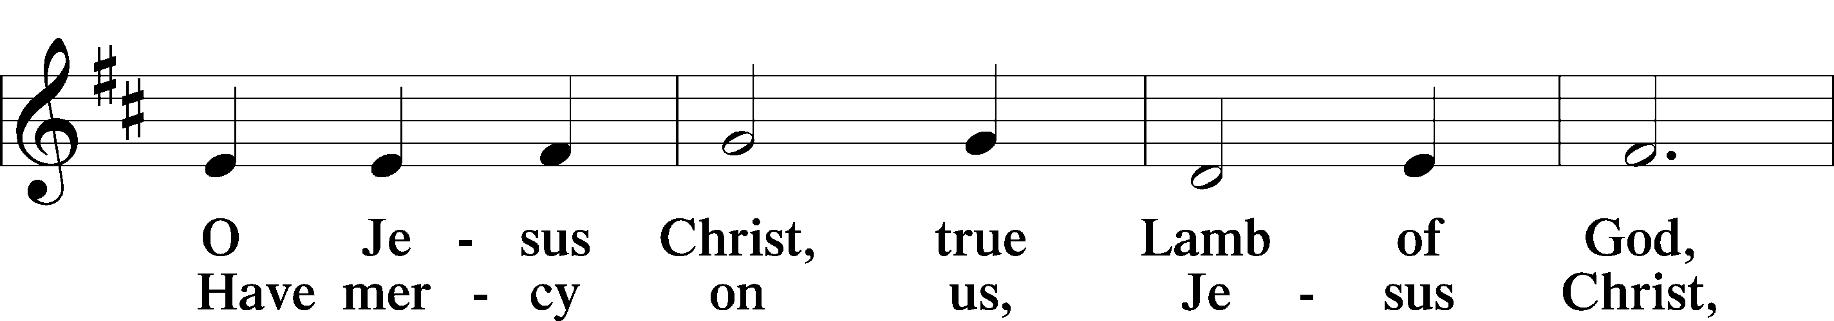
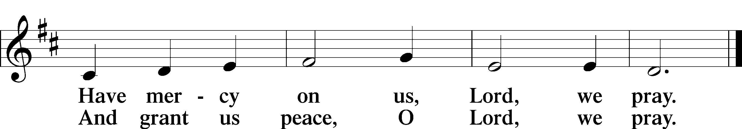

Please be seated

DISTRIBUTION
The pastor and those who assist him receive the body and blood of Christ first, then Communion will be served at the rail. Ushers will help direct you forward via the center aisle; please return to your seats via the side aisles. Gluten-free bread is available for those who need it, as is non-alcoholic grape juice. Simply request either when you come forward to receive Communion.
DISTRIBUTION HYMN
At the Lamb’s High Feast We Sing LSB 633
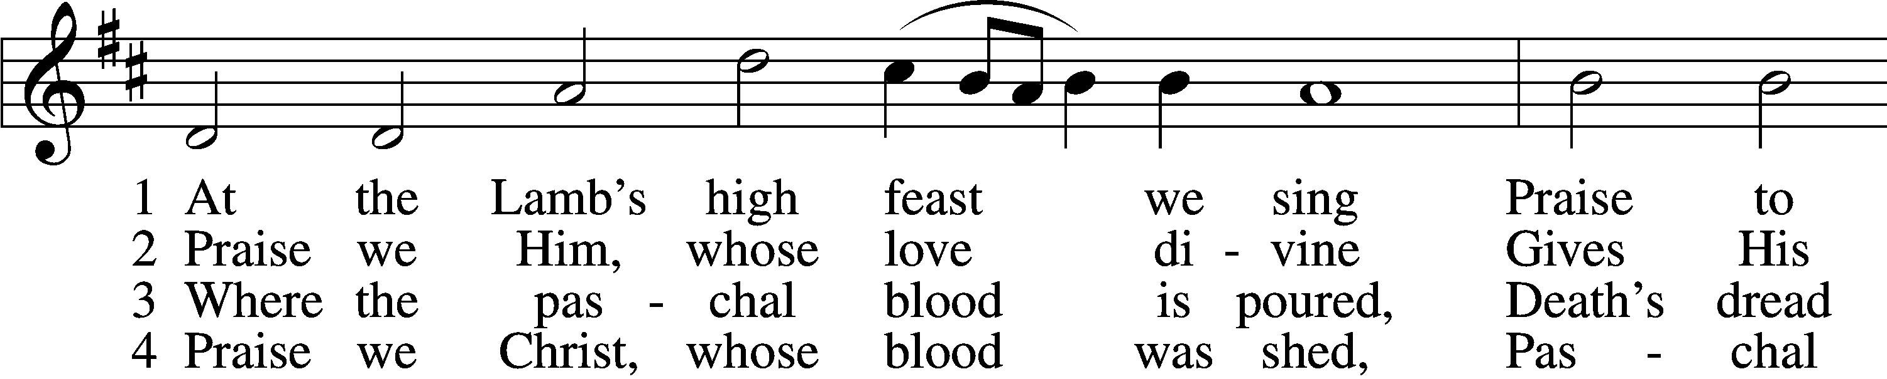
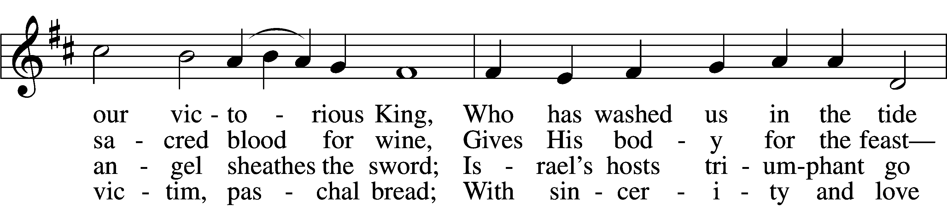
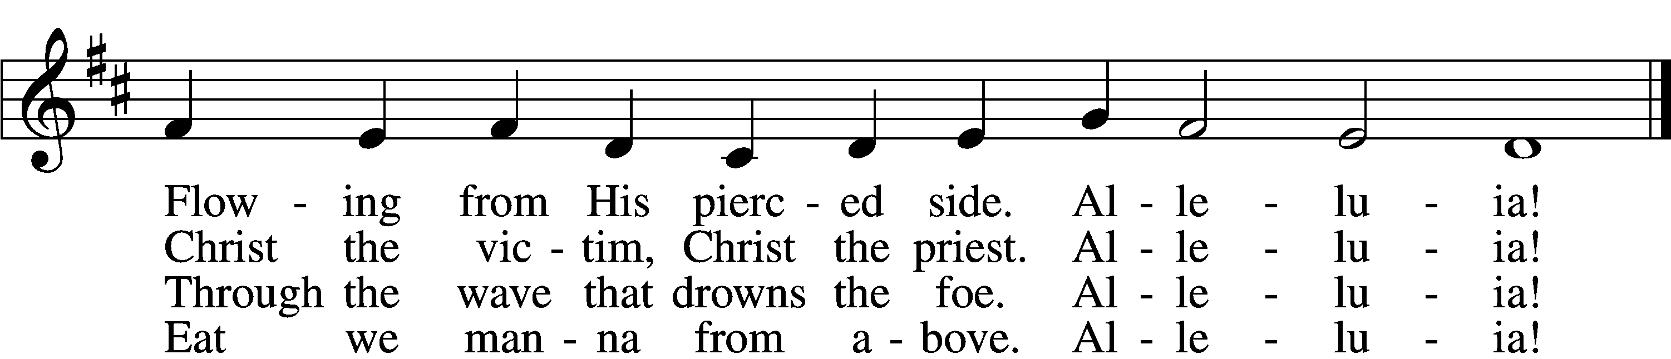

5 Mighty Victim from the sky,
Hell’s fierce pow’rs beneath You lie;
You have conquered in the fight,
You have brought us life and light.
Alleluia!

6 Now no more can death appall,
Now no more the grave enthrall;
You have opened paradise,
And Your saints in You shall rise.
Alleluia!

7 Easter triumph, Easter joy!
This alone can sin destroy;
From sin’s pow’r, Lord, set us free,
Newborn souls in You to be.
Alleluia!

8 Father, who the crown shall give,
Savior, by whose death we live,
Spirit, guide through all our days:
Three in One, Your name we praise.
Alleluia!

DISTRIBUTION HYMN
Let the Vineyards Be Fruitful LSB 955
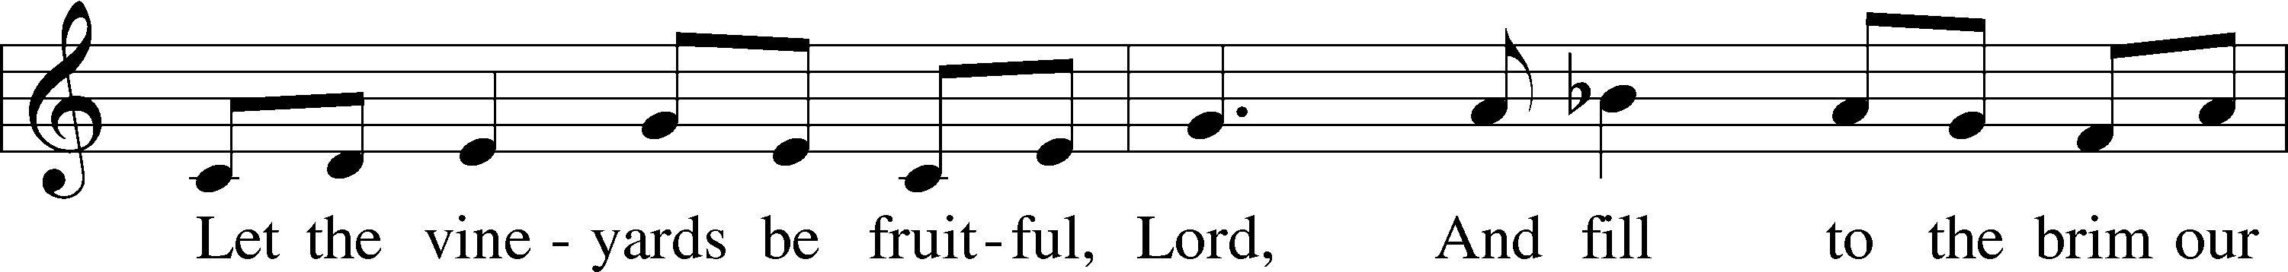
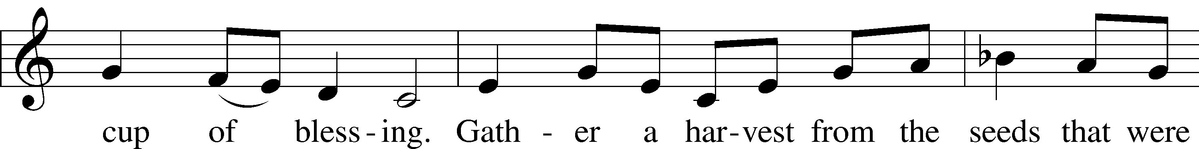
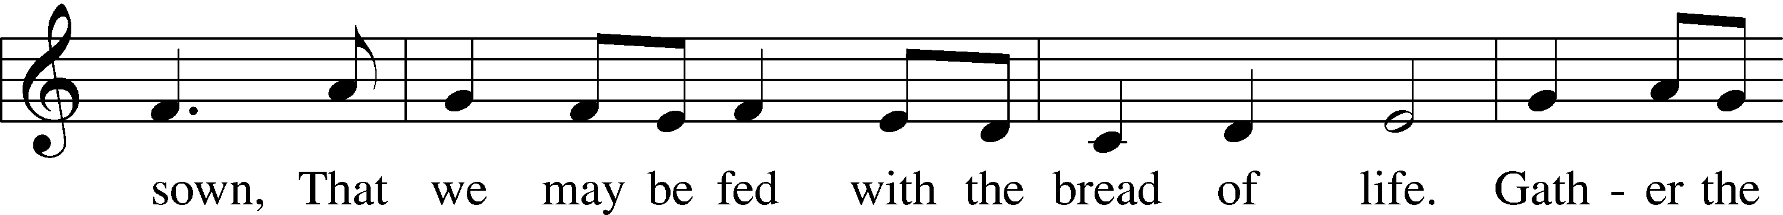
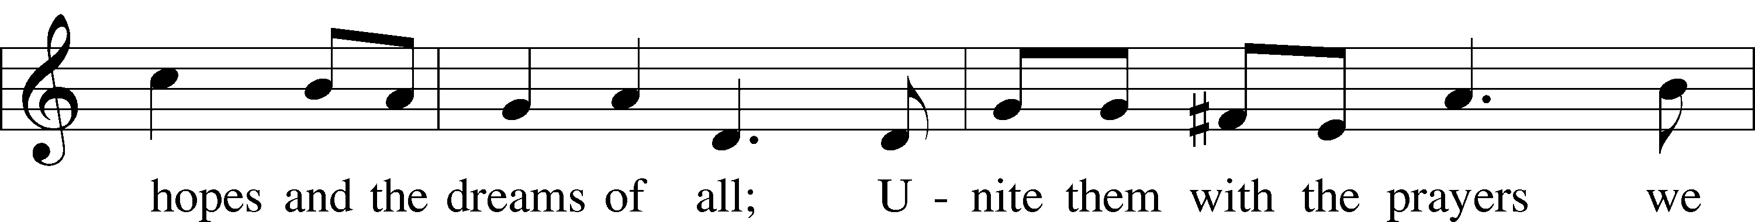
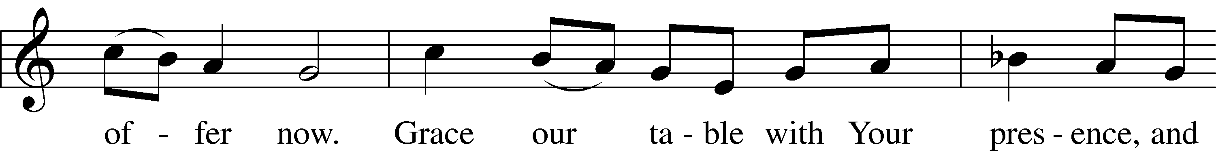
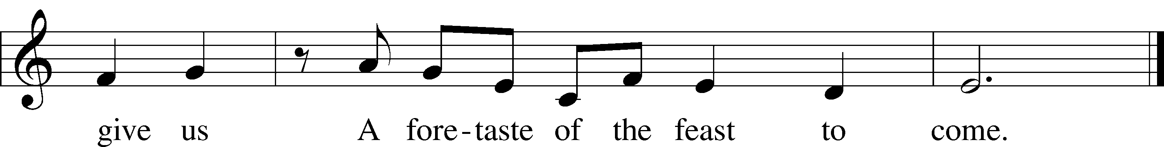

Please stand as able

NUNC DIMITTIS LSB 211
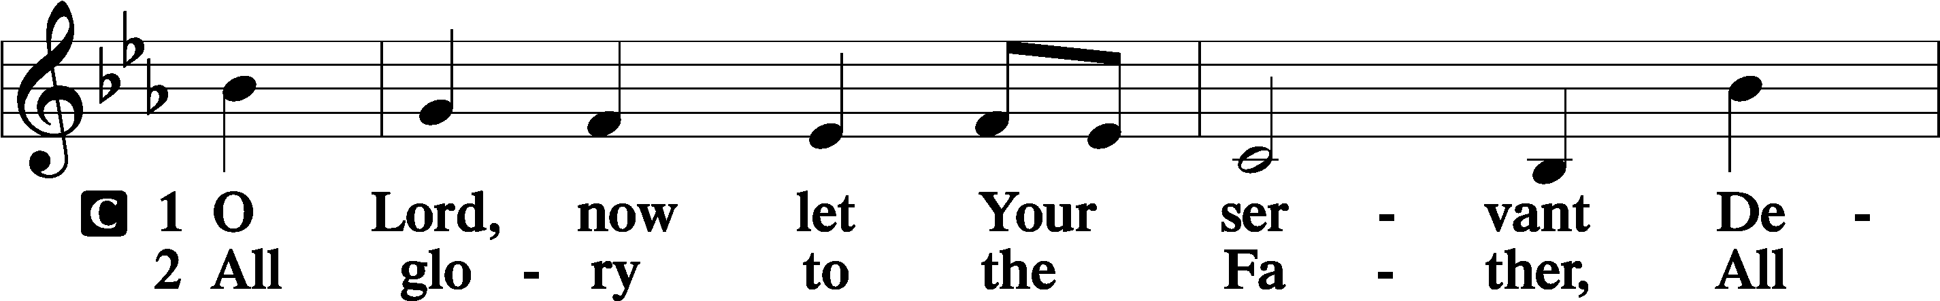
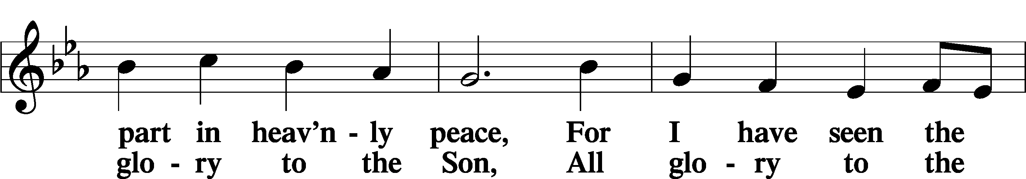
Continued on next page
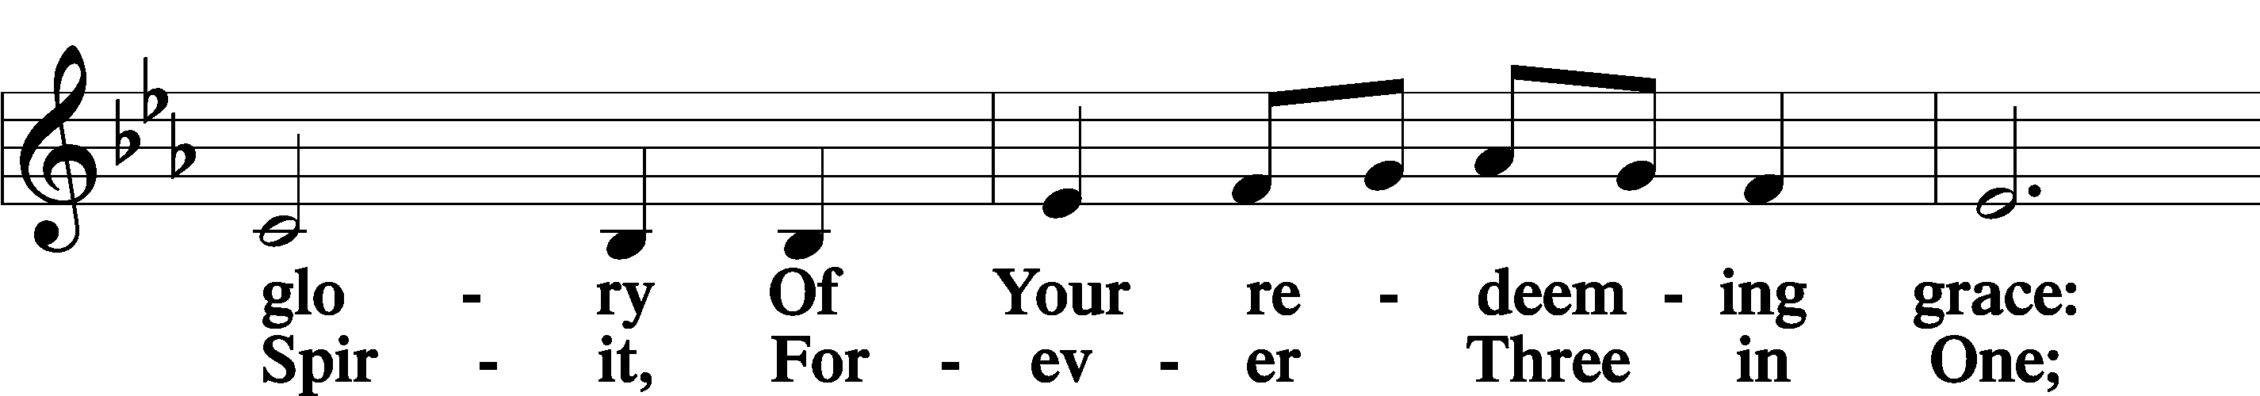
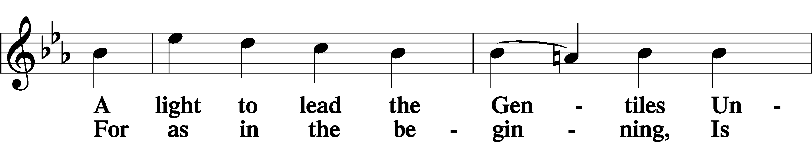
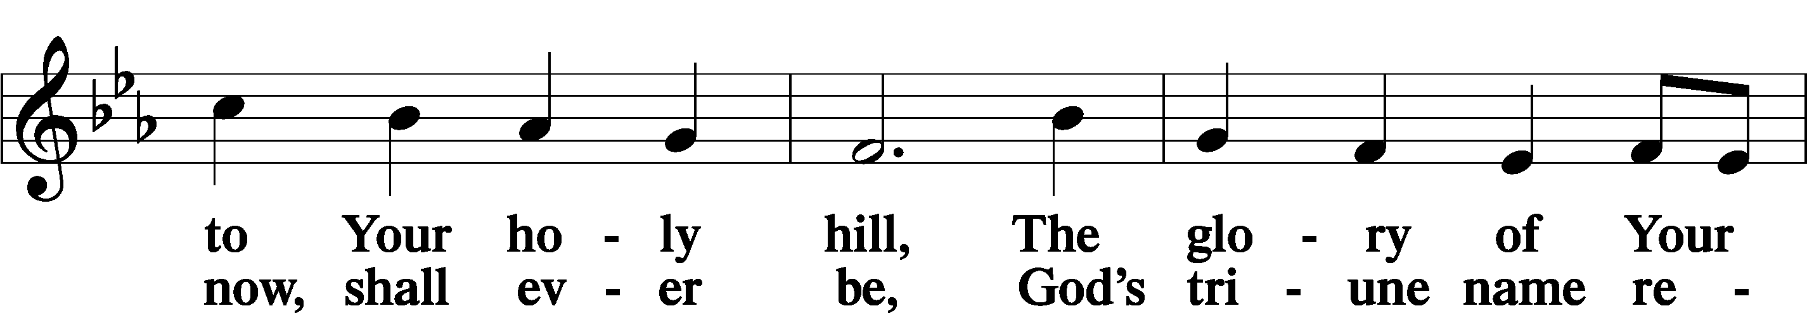
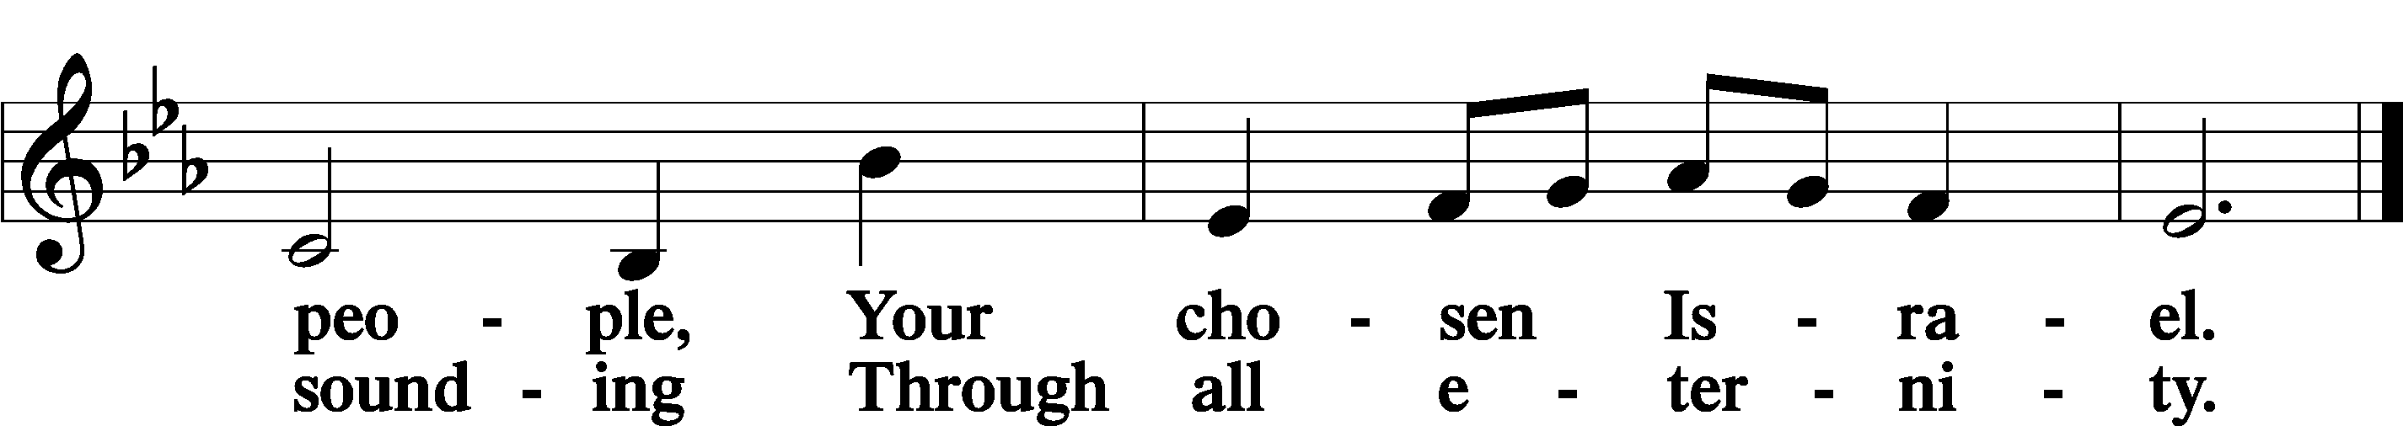

POST COMMUNION COLLECT
P Let us pray.
We give thanks to You, almighty God, that You have refreshed us through this salutary gift, and we implore You that of Your mercy You would strengthen us through the same in faith toward You and in fervent love toward one another; through Jesus Christ, Your Son, our Lord, who lives and reigns with You and the Holy Spirit, one God, now and forever.
C Amen.
BENEDICAMUS LSB 212
P Let us bless the Lord.
C Thanks be to God.
BENEDICTION
P The Lord bless you and keep you.
The Lord make His face shine on you and be gracious to you.
The Lord look upon you with favor and T give you peace.
C Amen.

Please be seated
CLOSING HYMN
Jesus, Lead Thou On LSB 718
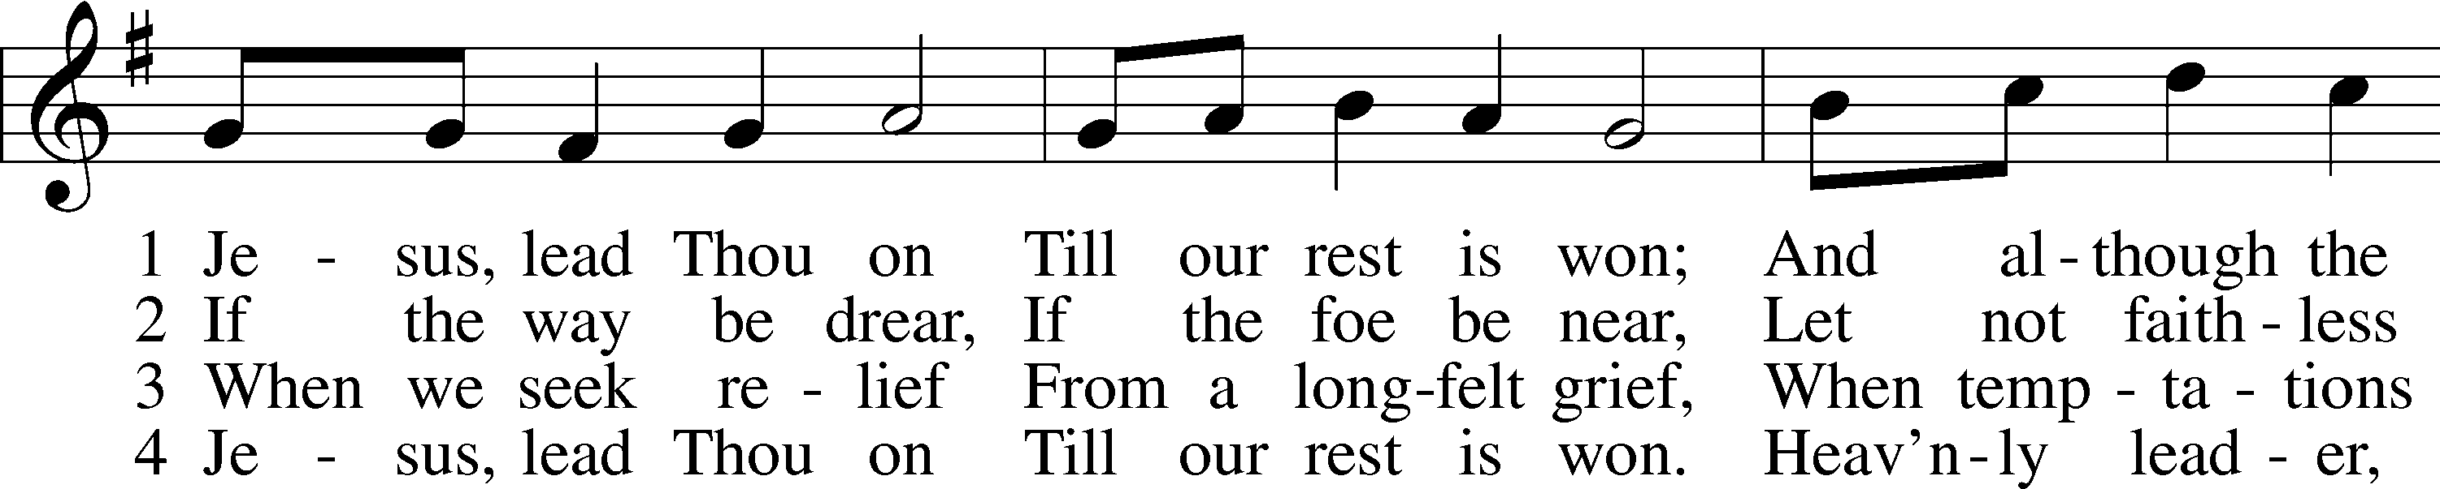
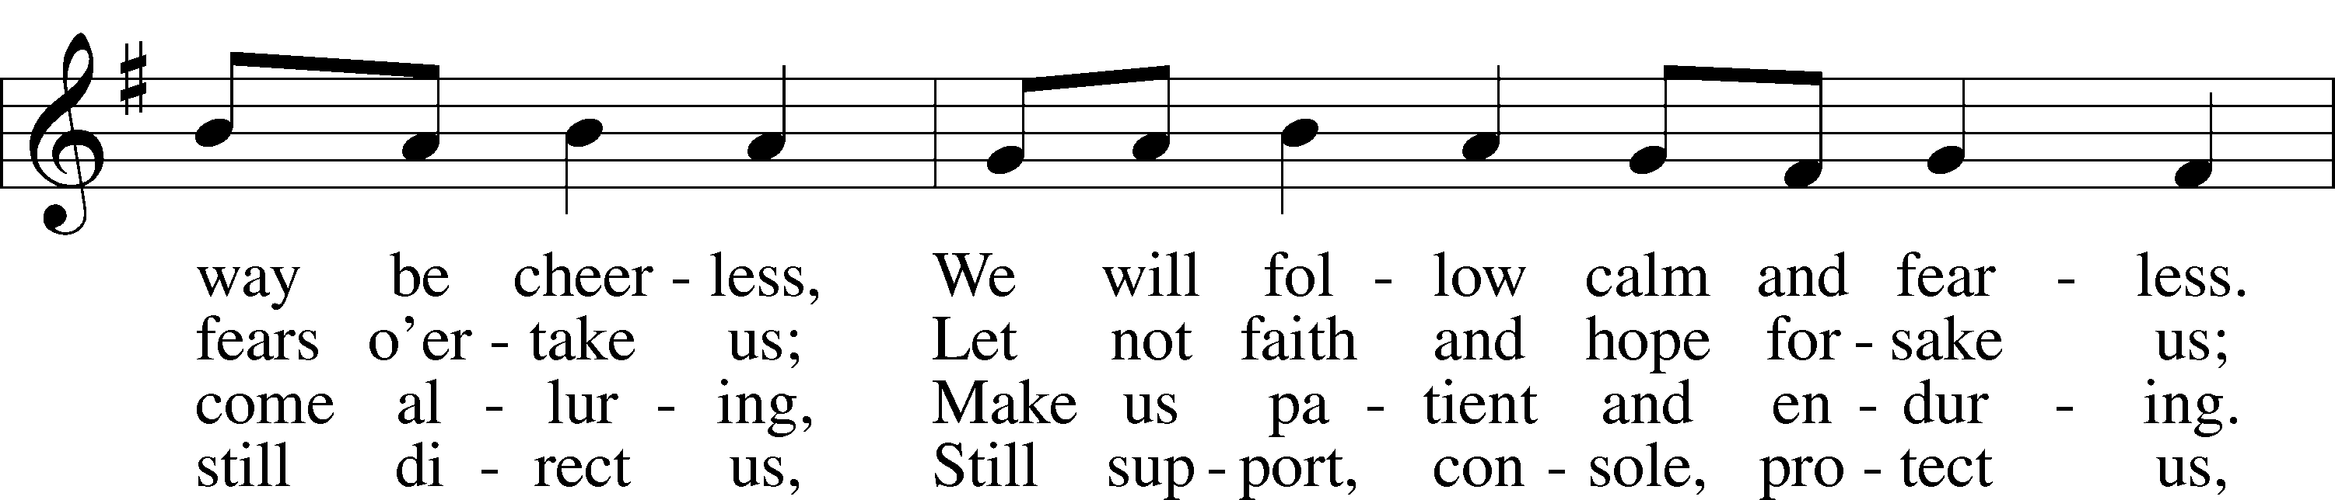
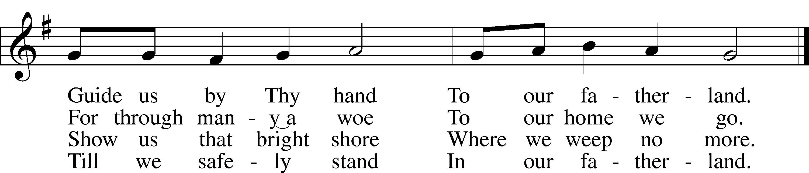

ANNOUNCEMENTS and SENDING WORDS
P We go to live for Jesus!
C We go to share His love!

Acknowledgments
Unless otherwise indicated, Scripture quotations are from the ESV® Bible (The Holy Bible, English Standard Version®), copyright 2001 by Crossway, a publishing ministry of Good News Publishers. Used by permission. All rights reserved. Created by Lutheran Service Builder. Music reproduced in this service is used with permission through: CCLI License No.1776588 and CPH – LSB Service Builder.

SERVING in GODS HOUSE TODAY
Pastor: Rev. Ken Bernthal
Elder: Glenn Smith
Ushers: Linda West, Risa Sherman
Greeters: Jack & Terri Osantowski
Counters: Donna Cottrell, La Verne Scheiterlein
Coffee Servers : LWML
Organ/Keyboard: Tom & Jean Beach
Altar Care: Donna Cottrell
Children’s Talk: Nancy Ely
Children’s Sunday School: Sharon Techel, Jean Beach and Nancy Ely
Sunday Morning Bible Study: w/ Dr. Tom Beach 10:30am
PRAYERS
Please contact the office with updates to the prayer list. People will remain on the prayer list for 4 weeks before being removed. If they need to remain on the list, please keep Elaine informed and of any updates. This will help us to have a more accurate list. Thanks for your cooperation.
Those who continue to grieve the passing of loved ones,.
Those with upcoming surgery: Tanner Beyers (and medical procedures), Greg Techel,
Those recovering from surgery: Roxy Mohr, Bill Stiles, Joann Whitney, and Jim (Joann Whitney’s brother-in-law).
Those with health concerns: Tiffany Amsdill, Wally Beasinger, Ruth Bennett (Sharron Kato’s Sister), Hope Buchinger, Betsy Cook, Paul Kietzman, Jennifer Martin, Eleanor Raether, Beth Smith, and Judi Stutzman.
Those diagnosed with cancer: Sue Cavanagh, (diagnosed with breast cancer). Leah Eicher, Rachel Frisch, Janice Knoellinger, Leslie Martin, Brian Morgan, and Hope Osantowski
Those under Hospice Home Care: Ken Williamson, Jim (Joann Whitney’s brother-in law).

BIRTHDAYS: ANNIVERSARIES;
11/14 Denise Lange 11/19 Rev. Paul & Karen Schneider
11/19 Tyler Appold

MESSAGES

ALTAR FLOWERS today were given to the glory of God from Stacey & Jason Buchinger in celebration of Hopes birthday.

MEMBER & GUEST CARDS: If you have not filled out a member/guest card, please take the time to fill one out and place it in the plate behind the back pews in our sanctuary.

WEDNESDAY MORNING BIBLE STUDY, 10:00am in the fellowship hall with Pastor Ken Bernthal.

GREETING CARDS If you are in need of some greeting cards, we carry an array of them in the cabinet across from the library. The cost of the cards is posted on the cabinet. The money collected from the cards goes to LWML to help support Missions.

CANCER and FRIENDS SUPPORT GROUP: Will be meeting on the fourth Tuesday of each month. Please remember Cancer & Friends Support Group is not just for people going through treatment, or survivors, we are also here for caregiver, spouse, children, and friends. There are times when we can all use someone to talk to during those difficult times. If there is any subject you would like to discuss with me you call or text or at 989-350-4391. Hope you will join us.

THANKSGIVING EVE SERVICE: We will be having a Thanksgiving Eve Service November 23rd at 7pm.
ANGEL TREE It's that time of year again. The Angel Christmas tree will be up in the Narthex it is adorned with Angels containing the names of children just waiting for you to go Christmas shopping for them. All you have to do is take the angel with a child’s name on it. When you return the gift (unwrapped) place it under the Angel tree. Gifts should be back by November 13th the latest is November 20th. Please, no food or candy. Thank you!

. SERVING in GODS HOUSE NEXT SUNDAY NOVEMBER 20
Pastor: Rev. Paul Schneider
Elder: Tom Raithel
Ushers: Terri Raithel, Ron Tesolin
Greeters: Ann & Ken Mertz
Altar Care: Karen Schneider
Counters: Wendell Smith, Karl Scheiterlein
Coffee Servers: Leslie Martin
Virtual Organist: Bob Erat
Children’s Talk: Nancy Ely
Children’s Sunday School: Sharon Techel, Jean Beach and Nancy Ely
Sunday Morning Bible Study: w/ Dr. Tom Beach 10:30am
THIS WEEK AT TRINITY
November 13 Sunday
9:00 am Worship Service – Rev. Ken Bernthal
10:00 am Fellowship & Coffee Hour
10:30 am Sunday Morning Bible Study W/ Dr. Tom Beach
10:30 am Children’s Sunday School
November 14 Monday
7:00 pm Choir
November 15 Tuesday
NEWSLETTER DEADLINE
5:00 pm LWML Meeting
November 16 Wednesday
10:00 am Wednesday Morning Bible Study W/ Pastor Ken Bernthal
November 17 Thursday
November 18 Friday
November 19 Saturday
November 20 Sunday
9:00 am Worship Service - Rev. Paul Schneider
10:00 am Fellowship & Coffee Hour
10:30 am Bible Study with Dr. Tom Beach (Tutoring Room)
10:30 am Children’s Sunday School

